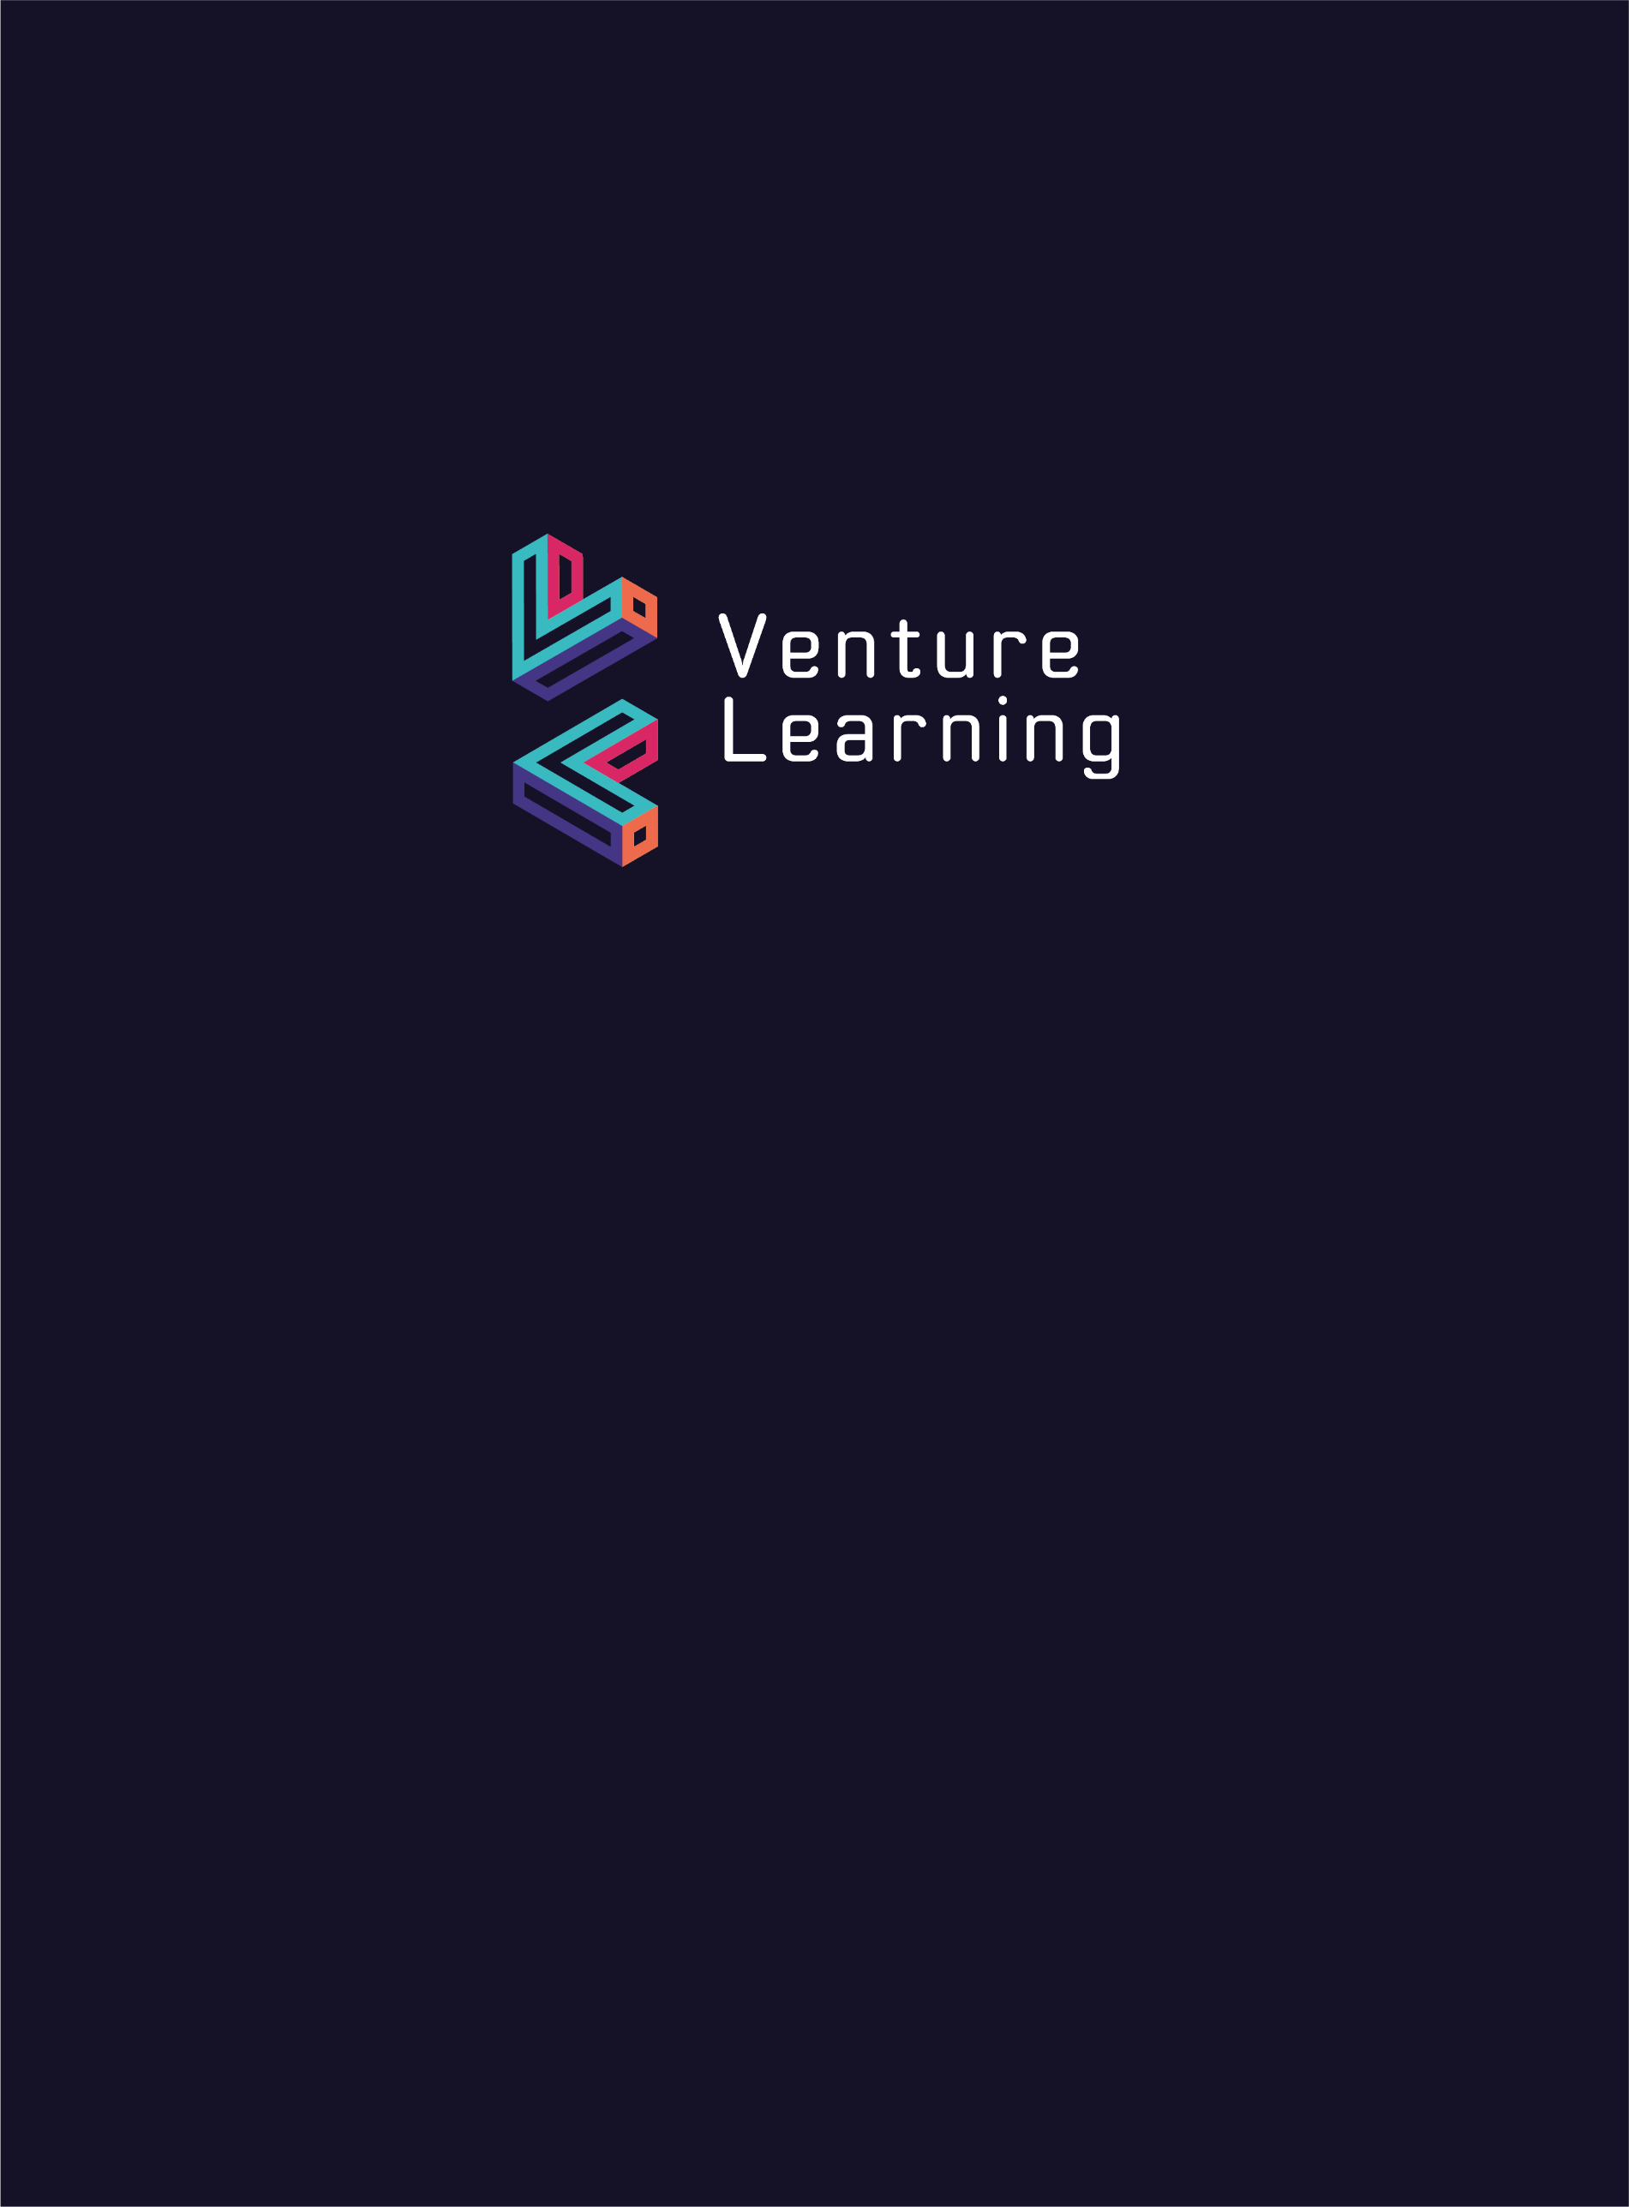

Remote Learning Policy
Venture Learning

Document Owner | Rhys Griffiths
Version | 2.0
Effective From | 06/01/2021
Next Review Date | 07/01/2022

Introduction
This policy has been written in line with Venture Learning’s Covid-19 Risk Assessment to ensure continuity of learning for students who are unable to access learning on-site as a result of the impact of Covid-19. This includes, but is not limited to:
- students who have been instructed to self-isolate at home;
- students who are instructed to shield;
- the event of a partial closure of the provision as a result of staffing shortages;
- the event of a partial closure of the provision (for example, a bubble) as a result of a student or staff member testing positive;
- the event of a full closure due to multiple students/staff members testing positive across the provision; or,
- the event of a full closure due to a local or national lockdown.
This policy does not apply if students are absent for sickness and unable to work from home. There is no obligation for Venture Learning to provide continuity of education to learners who absent themselves from school, with or without parental permission, in contravention to school or government guidance. This may apply, for example, if parents choose to take students on holiday during term time. Similarly, this would apply if parents made the decision, without prior agreement with the school, to absent their children from school ‘as a precaution’, against official guidance.
This policy has been updated to adhere to the Temporary Continuity Direction coming into force on 22/10/20.
This policy has been written in response to a dynamic and ongoing problem. As a result, it should be reviewed and updated regularly to ensure it reflects our continuously improving practice in response to the current situation as well as any changes to local and national guidelines.

Key Staff and Contacts

Provision Based Contacts
Name | Role
Rhys Griffiths | Head of Provision
Rich Hill | Deputy Head of Provision
Contact details: | Venture Learning  19A Forester Street  Netherfield  Nottingham  NG4 2LJ
 | www.venturelearning.co.uk
 | 0115 987 6621

Section 1: Roles and Responsibilities
Venture Learning has a legal duty to provide remote education for state-funded, school-age children unable to attend school due to coronavirus (COVID-19) as of 22/10/20. This must be provided immediately from the point that the student/class/bubble/whole provision is asked to remain at home by either the provision, or by official instruction.
  - Head of Provision
The Head of Provision is responsible for implementing, sharing and monitoring this policy. This includes:
- ensuring that the curriculum for all subjects is of high-quality and appropriate for being communicated through online and remote learning;
- ensuring that all online learning platforms are set up and accessible for all staff and students;
- ensuring that teaching staff have the appropriate resources to deliver their curriculum remotely;
- ensuring that remote teaching delivered is of a high quality;
- ensuring that students and parents understand how to access remote learning from home and implementing support where necessary; and,
- monitoring and reviewing the effectiveness of remote education.

  - Teaching Staff
Named staff members are responsible for monitoring the standard of remote education for each key stage. Holly Crann is responsible for KS3. Louise Schofield is responsible for KS4. These staff are responsible for ensuring that:
- students have meaningful and ambitious work each day in a number of different subjects;
- a planned and well-sequenced curriculum is taught so that knowledge and skills are built incrementally, with a good level of clarity about what is intended to be taught and practised in each subject;
- there are frequent, clear explanations of new content, delivered by a teacher in the school or through high-quality curriculum resources or videos;
- teaching staff are gauging how well students are progressing through the curriculum, using questions and other suitable tasks and set a clear expectation on how regularly teachers will check work;
- teachers adjust the pace or difficulty of what is being taught in response to questions or assessments, including, where necessary, revising material or simplifying explanations to ensure students' understanding;
- the programme is of equivalent length to the core teaching students would receive on site, with regular contact with teachers.
All teaching staff are responsible for planning and resourcing remote learning that is in line with the curriculum aims and learning objectives being delivered on-site.

Section 2: Remote Learning Procedures
2.1. Core Curriculum
- All students must be provided with Maths and English work for each day they are off.
- All new concepts must be accompanied with an appropriate explanatory video.
- Maths will remain in line with the provision curriculum by following White Rose Maths.
- Oak Academy will be used for the provision of English home learning videos – teachers must carefully select videos and resources to correspond with the learning objectives being taught on site for the period of remote learning. These learning objectives must be outlined in the curriculum/scheme of work for English on site to ensure that they are relevant and progressive.
2.2. Additional Subjects
Students must be provided with a broad and balanced curriculum whilst learning from home. Venture Learning will provide the following per week to reflect the subject learning on site:
- 1/2 PSHE lessons
- 2/3 Topic lessons
- 1/2 Art lessons
These lessons must be provided with more than just worksheets/resources. Some form of online teaching must be provided (e.g. a video, direct online teaching or an interactive powerpoint). They may be adapted to make them accessible at home but they should maintain the same theme and learning objective as what is being taught on site.
Unfortunately students will not be able to access PE or cooking lessons from home.
2.3. Delivery of Resources
- Venture Learning must first explore a student’s ability to access the internet from home. If the student has a computer or can be provided with a laptop by Venture Learning, work and links for online learning may be emailed to students.
- Where work needs to be printed Venture Learning will provide printed copies of the relevant resources. These should be delivered by hand where possible to ensure students have them in time. Where this is impossible, resources may be sent through the post.
- If students are waiting for resources to be delivered they must be set a relevant and meaningful assignment to complete during the waiting period to ensure that remote learning takes place with immediate effect.
2.4. Teacher Contact
Teachers must maintain regular contact with students who are learning remotely. This should be at least 3 times per week for full time students, twice per week for part time students. Ideally this should occur through an online learning platform like Microsoft Teams. Where this is not possible, for example, for technology or engagement reasons, another form of contact can be used as substitute.
Students should receive regular feedback on work. Marking should occur at least once per week and work should be adapted in response to maintain student understanding, engagement and progress.

