Peer on Peer Policy
Venture Learning

Document Owner | Rhys Griffiths
Version | V1
Effective From | Sept 2021
Next Review Date | August 2022

I The School’s responsibilities
Introduction
The senior leadership team, and all staff (which term shall apply to all volunteer staff members) at Venture Learning (the School) are committed to the prevention, early identification, and appropriate management of peer-on-peer abuse (as defined below) both within and beyond the School.
In particular, we:
• believe that in order to protect children, all schools should (a) be aware of the nature and level of risk to which their students are or may be exposed, and put in place a clear and comprehensive strategy which is tailored to their specific safeguarding context; and (b) take a whole-school community Contextual Safeguarding approach to preventing and responding to peer-on-peer abuse,
• regard the introduction of this policy as a preventative measure. We (a) do not feel it is acceptable merely to take a reactive approach to peer-on-peer abuse in response to alleged incidents of it; and (b) believe that in order to tackle peer-on-peer abuse proactively, it is necessary to focus on all four of the following areas: (i) systems and structures; (ii) prevention; (iii) identification; and (iv) response/intervention,
• recognise national and increasing concern about this issue, and wish to implement this policy in order to mitigate harmful attitudes and peer-on-peer abuse in the school setting, and
• encourage parents to hold us to account on this issue, so that if their child is feeling unsafe as a result of the behaviour of any of their peers, they should inform the School so that it can ensure that appropriate and prompt action is taken in response.

This policy
This policy:
• is Venture Learning’s overarching policy for any issue that could constitute peer-on-peer abuse. It relates to, and should be read alongside, the School’s child protection policy and any other relevant policies including, but not limited to, bullying (including cyber-bullying), youth involved sexual imagery, online safety, IT use, data protection and retention of records, children missing in education, student behaviour and discipline, exclusions, and (where relevant) weapons,
• sets out our strategy for improving prevention, and identifying and appropriately managing peer-on-peer abuse.
• applies to all (the senior leadership team, staff and volunteers). It is reviewed annually, and updated in the interim, as may be required, to ensure that it continually addresses the risks to which students are or may be exposed. A number of staff and students are involved in each annual review which involves, and is informed by, an assessment of the impact and effectiveness of this policy over the previous year,
• recognises that abuse is abuse, and should never be passed off as ‘banter’, ‘just having a laugh’, or ‘part of growing up’,
• is compliant with the statutory guidance on peer-on-peer abuse as set out in Keeping Children Safe in Education (September 2021),
• does not use the term ‘victim’ and/or ‘perpetrator’. This is because our School takes a safeguarding approach to all individuals involved in concerns or allegations about peer-on-peer abuse, including those who are alleged to have been abused, and those who are alleged to have abused their peers, in addition to any sanctioning work that may also be required for the latter. Research has shown that many children who present with harmful behaviour towards others, in the context of peer-on-peer abuse, are themselves vulnerable and may have been victimised by peers, parents or adults in the community prior to their abuse of peers,
• uses the terms ‘child’ and ‘children’, which is defined for the purposes of this policy as a person aged under 18.
• should, if relevant, according to the concern(s) or allegation(s) raised, be read in conjunction with the DfE’s advice on Sexual Violence and Sexual Harassment Between Children in Schools and Colleges (DfE’s Advice) (May 2018), and any other advice and guidance referred to within it, as appropriate, and
• should be read in conjunction with the Local Safeguarding Partnership’s Safeguarding Policy and Procedures, and any relevant Practice Guidance issued by it.

II Understanding peer-on-peer abuse
What is peer-on-peer abuse?
For these purposes, peer-on-peer abuse is any form of physical, sexual, emotional and financial abuse, and coercive control, exercised between children, and within children’s relationships (both intimate and non-intimate), friendships and wider peer associations. Peer-on-peer abuse can take various forms, including (but not limited to): serious bullying (including cyber-bullying), relationship abuse, domestic violence and abuse, child sexual exploitation, youth and serious youth violence, harmful sexual behaviour, and/or prejudice-based violence including, but not limited to, gender-based violence.
Examples of online peer-on-peer abuse would include sexting, online abuse, peer-on-peer grooming, the distribution of youth involved sexualised content, and harassment.

Holistic account of peer-on-peer abuse
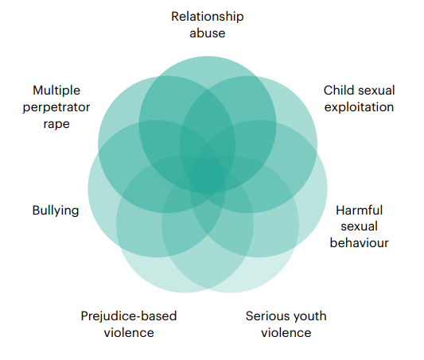

Contextual circles of adolescent vulnerability
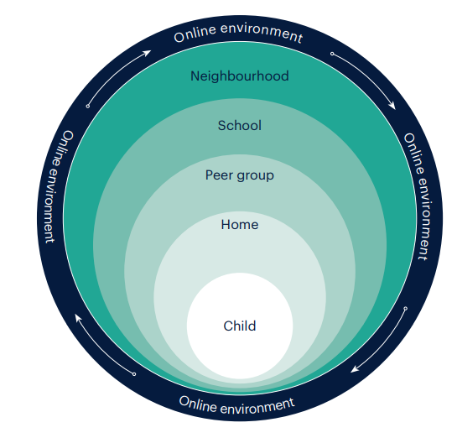

What is Contextual Safeguarding?
This policy:
(a) encapsulates a Contextual Safeguarding approach, which is about changing the way that professionals approach child protection when risks occur outside of the family, thereby requiring all those within a Local Safeguarding Partnership to consider how they work alongside, rather than just refer into, children’s social care, to create safe spaces in which children may have encountered peer-on-peer abuse.
(b) adopts a whole-school community Contextual Safeguarding approach, which means:
• being aware of and seeking to understand the impact that these wider social contexts may be having on the School’s students,
• creating a safe culture in the School by, for example, implementing policies and procedures that address peer-on-peer abuse and harmful attitudes; promoting healthy relationships and attitudes to gender/ sexuality; hotspot mapping to identify risky areas in the School; training on potential bias and stereotyped assumptions,
• being alert to and monitoring changes in students’ behaviour and/or attendance, and
• contributing to local child protection agendas by, for example, challenging poor threshold decisions and referring concerns about contexts to relevant local agencies (see section entitled ‘multi-agency working’).

How prevalent is peer-on-peer abuse?
Research suggests that peer-on-peer abuse is one of the most common forms of abuse affecting children in the UK. For example, [more than four in ten teenage schoolgirls aged between 13 and 17 in England have experienced sexual coercion. Two thirds of contact sexual abuse experienced by children aged 17 or under was committed by someone who was also aged 17 or under.
When does behaviour become problematic or abusive?
All behaviour takes place on a spectrum. Understanding where a child’s behaviour falls on a spectrum is essential to being able to respond appropriately to it.
Sexual behaviours
Simon Hackett has proposed the following continuum model to demonstrate the range of sexual behaviours presented by children, which may be helpful when seeking to understand a student’s sexual behaviour and deciding how to respond to it.

Sexual Behaviours Continuum Model.
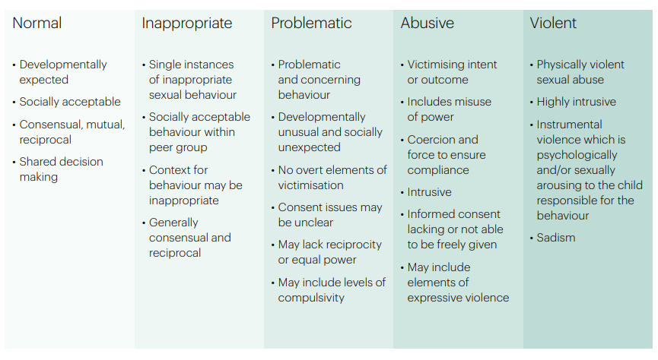
Hackett’s continuum relates exclusively to sexual behaviours and is not exhaustive. In addition, the DSL for Venture Learning has also completed training to be able to access and use The Brook Sexual Behaviours Traffic Light Tool. This can further aid all professionals working with our children to distinguish between three levels of sexual behaviour – green, amber and red, and to respond according to the level of concern.
INSERT BROOK TRAFFIC LIGHT TOOL.

Other behaviour
When dealing with other alleged behaviour which involves reports of, for example, emotional and/or physical abuse, staff can draw on aspects of Hackett’s continuum to assess where the alleged behaviour falls on a spectrum and to decide how to respond. This could include, for example, whether it:
• is socially acceptable,
• involves a single incident or has occurred over a period of time,
• is socially acceptable within the peer group,
• is problematic and concerning,
• involves any overt elements of victimisation or discrimination e.g. related to race, gender, sexual orientation, physical, emotional, or intellectual vulnerability,
• involves an element of coercion or pre-planning,
• involves a power imbalance between the child/ children allegedly responsible for the behaviour and the child/children allegedly the subject of that power, and
• involves a misuse of power.
How can a child who is being abused by their peers be identified?
All staff should be alert to the well-being of students and to signs of abuse, and should engage with these signs, as appropriate, to determine whether they are caused by peer-on-peer abuse. However, staff should be mindful of the fact that the way(s) in which children will disclose or present with behaviour(s) as a result of their experiences will differ.
Looking behind students’ behaviour.
At Venture Learning, the DSL and Deputy DSL should regularly review behaviour incident logs which can help to identify any changes in behaviour and/or concerning patterns or trends at an early stage. In the context of our small provision, the review process should involve all permanent staff as appropriate. In addition training will be provided so that all staff can recognise signs, be exercising vigilance and feel confident in raising changes in behaviour and/or patterns.
Are some children particularly vulnerable to abusing or being abused by their peers?
Any child can be vulnerable to peer-on-peer abuse due to the strength of peer influence during adolescence, and staff should be alert to signs of such abuse amongst all children. In the context of Venture Learning as an alternative provision, ALL of our students are considered to be vulnerable.
Individual and situational factors can increase a child’s vulnerability to abuse by their peers. For example, an image of a child could be shared, following which they could become more vulnerable to peer-on-peer abuse due to how others now perceive them, regardless of any characteristics which may be inherent in them and/or their family. At Venture Learning, all staff need to be alert to any historical context for each student and any previous connections they may have to other students attending our school. This is also relevant for when students transition back into mainstream school, and appropriate sharing of information will be necessary to safeguard the student.
Peer group dynamics can also play an important role in determining a child’s vulnerability to such abuse. At Venture Learning we will certainly have children who are more likely to follow others and/or who are socially isolated from their peers and therefore, may be more vulnerable to peer-on-peer abuse.
Children who are questioning or exploring their sexuality may also be particularly vulnerable to abuse by their peers.
Research suggests that:
• peer-on-peer abuse may affect boys differently from girls, and that this difference may result from societal norms (particularly around power, control and the way in which femininity and masculinity are constructed) rather than biological make-up. Barriers to disclosure will also be different. As a result, we need to explore the gender dynamics of peer-on-peer abuse within our setting, and recognise that these will play out differently in single sex, mixed or gender- imbalanced groups,
• children with Special Educational Needs and/or Disabilities (SEND) are three times more likely to be abused than their peers without SEND. In the context of Venture Learning, we are more likely to have a high proportion of SEND students and all staff need to be aware of additional barriers can sometimes exist when recognising abuse in children with SEND.
These can include:
− assumptions that indicators of possible abuse such as behaviour, mood and injury relate to a child’s disability without further exploration,
− the potential for children with SEND to be disproportionately impacted by behaviours such as bullying and harassment, without outwardly showing any signs,
− communication barriers and difficulties, and
− overcoming these barriers.
• some children may be more likely to experience peer-on-peer abuse than others as a result of certain characteristics such as sexual orientation, ethnicity, race or religious beliefs.

III A Whole School Approach.
School environment
Venture Learning actively seeks to raise awareness of and prevent all forms of peer-on-peer abuse by:
- educating our senior leadership team, staff, students, and parents about this issue. This includes: training our senior leadership team, and staff on the nature, prevalence and effect of peer-on-peer abuse, and how to prevent, identify, and respond to it. This includes:
- contextual Safeguarding,
- the identification and classification of specific behaviours, including digital behaviours,
- the importance of taking seriously all forms of peer-on-peer abuse (no matter how ‘low level’ they may appear) and ensuring that no form of peer-on-peer abuse is ever dismissed as horseplay or teasing, and
- social media and online safety, including how to encourage children to use social media in a positive, responsible and safe way, and how to enable them to identify and manage abusive behaviour online.
- educating children about the nature and prevalence of peer-on-peer abuse, positive, responsible and safe use of social media, and the unequivocal facts about consent, via PSHE and the wider curriculum. Students should be frequently told what to do if they witness or experience such abuse, the effect that it can have on those who experience it and the possible reasons for it, including vulnerability of those who inflict such abuse. They are regularly informed about the our approach to such issues, including our zero-tolerance policy towards all forms of peer-on-peer abuse. Educating students about consent includes teaching them basic facts such as (i) a child under the age of 13 can never consent to any sexual activity; (ii) the age of consent is 16; and (iii) sexual intercourse without consent is rape, and

- engaging our parents on these issues by:
- talking about them with parents,
- asking parents what they perceive to be the risks facing their child and how they would like to see Venture Learning address those risks,
- encouraging parents to hold Venture Learning to account on this issue, in part as a result of visibility of this policy,

- supporting the on-going welfare of the student body by drawing on multiple resources that prioritise student mental health, and by providing in-school counselling and therapy to address underlying mental health needs. These interventions are ‘de-clinicised’ and brokered through a positive relationship with the Venture Learning and its staff. All staff are trained to meet low-level mental health difficulties within the students,

- working with the senior leadership team, and all staff, students and parents to address equality issues, to promote positive values, and to encourage a culture of tolerance and respect amongst all members of our community,

- creating conditions in which our students can aspire to, and realise, safe and healthy relationships fostering a whole-school culture:

  - which is founded on the idea that every member of our School community is responsible for building and maintaining safe and positive relationships, and helping to create a safe School environment in which violence and abuse are never acceptable, and in which certain behaviour such as the carrying of weapons is not tolerated,
  - in which our students are able to develop trusting relationships with staff, and in which staff understand, through regular discussion and training, the importance of these relationships in providing our students with a sense of belonging, which could otherwise be sought in problematic contexts,
  - in which our students feel able to share their concerns openly, in a non-judgmental environment, and have them listened to,
  - which (i) proactively identifies positive qualities in our students; (ii) nurtures these qualities; (iii) teaches and encourages our students to think about positive hopes for the future; and (vi) supports our students in developing small-scale goals that enable realistic ambitions, and
  - which provides supervised activities to students that give them the experience of having their needs met that might otherwise apparently be met in abusive circumstances. These can include experiencing (i) status; (ii) excitement; and (iii) a degree of risk,

- responding to cases of peer-on-peer abuse promptly and appropriately, and

- ensuring that all peer-on-peer abuse issues are fed back to our safeguarding lead so that they can spot and address any concerning trends and identify students who may be in need of additional support. This is done by way of a weekly/fortnightly/monthly staff meeting at which all concerns about students (including peer-on-peer abuse issues) are discussed;

- challenging the attitudes that underlie such abuse (both inside and outside the classroom).

Multi-agency working
Venture Learning will actively engages with our Local Safeguarding Partnership in relation to peer-on-peer abuse, and works closely with, for example, Children & Families Direct (Nottingham City), Nottinghamshire Children and Families Alliance, the police, and our commissioning schools/agencies. Venture Learning will continue to actively engage with our local Provider Network Meetings and the Nottingham City DSL Network meetings. The relationships our school has built with these partners are essential to ensuring that we are able to prevent, identify early, and appropriately handle cases of peer-on-peer abuse. They help Venture Learnig to:
- develop a good awareness and understanding of the different referral pathways that operate in both Nottinghamshire and Nottingham City, as well as the preventative and support services which exist;
- ensure that its students are able to access the range of services and support they need quickly;
- support and help inform the our local community’s response to peer-on-peer abuse;
- increase our awareness and understanding of any concerning trends and emerging risks in our local area to enable it to take preventative action to minimise the risk of these being experienced by our students. Venture Learning is already signed up to local police alerts for our immediate community and the wider city and county areas.
Venture Learning will actively refer concerns and allegations of peer-on-peer abuse where necessary to children’s social care, the police, Children & Families Direct (Nottinghan City) and Nottinghamshire Children and Families Alliance. This is particularly important because peer-on-peer abuse can be a complex issue, and even more so where wider safeguarding concerns exist. It is often not appropriate for one single agency (where the alleged incident cannot appropriately be managed internally by the School itself) to try to address the issue alone, it requires effective partnership working.

IV Responding to concerns or allegations of peer-on-peer abuse
General principles
It is essential that all concerns and allegations of peer-on-peer abuse are handled sensitively, appropriately and promptly. The way in which they are responded to can have a significant impact on our School environment. Any response should:
- include a thorough investigation of the concern(s) or allegation(s), and the wider context in which it/they may have occurred (as appropriate) – depending on the nature and seriousness of the alleged incident(s), it may be appropriate for the police and/or children’s social care to carry out this investigation,

- treat all children involved as being at potential risk – while the child allegedly responsible for the abuse may pose a significant risk of harm to other children, s/he may also have considerable unmet needs and be at risk of harm themselves. Venture Learning should ensure that a safeguarding response is in place for both the child who has allegedly experienced the abuse, and the child who has allegedly been responsible for it, and additional sanctioning work may be required for the latter,

- take into account:

  - that the abuse may indicate wider safeguarding concerns for any of the children involved, and consider and address the effect of wider sociocultural contexts – such as the child’s/ children’s peer group (both within and outside the School); family; the School environment; their experience(s) of crime and victimisation in the local community; and the child/children’s online presence. Consider what changes may need to be made to these contexts to address the child/ children’s needs and to mitigate risk, and
  - the potential complexity of peer-on-peer abuse and of children´s experiences, and consider the interplay between power, choice and consent. While children may appear to be making choices, if those choices are limited they are not consenting,
  - the views of the child/children affected. Unless it is considered unsafe to do so (for example, where a referral needs to be made immediately), the DSL should discuss the proposed action with the child/ children and their parents, and obtain consent to any referral before it is made. Venture Learning should manage the child/children’s expectations about information sharing, and keep them and their parents informed of developments, where appropriate and safe to do so. It is particularly important to take into account the wishes of any child who has allegedly been abused, and to give that child as much control as is reasonably possible over decisions regarding how any investigation will be progressed and how they will be supported.
What should our staff do if they suspect either that a child may be at risk of or experiencing abuse by their peer(s), or that a child may be at risk of abusing or may be abusing their peer(s)?
If a member of Venture Learning staff thinks for whatever reason that a child may be at risk of or experiencing abuse by their peer(s), or that a child may be at risk of abusing or may be abusing their peer(s), they should discuss their concern with the DSL and/or Deputy DSL without delay (in accordance with section 12.3 our safeguarding policy) so that a course of action can be agreed. Any concerns and actions should also be logged asap using CPOMs.
Where a child is suffering, or is likely to suffer from harm, it is important that a referral to children’s social care (and, if appropriate, the police) is made immediately.
Anyone can make a referral. Where referrals are not made by the DSL, the DSL should be informed as soon as possible that a referral has been made (in accordance with section 20 of our safegaurding policy).
If a child speaks to a member of our staff about peer-on-peer abuse that they have witnessed or are a part of, the member of staff should listen to the child and use open language that demonstrates understanding rather than judgement. For further details please see the procedures set out in section 12.3 of our safeguarding policy.

How will the School respond to concerns or allegations of peer-on-peer abuse?
The DSL will discuss the concern(s) or allegation(s) with the member of staff who has reported it/them and will, where necessary, take any immediate steps to ensure the safety of the child/all children affected. Where any concern(s) or allegation(s) indicate(s) that indecent images of a child or children may have been shared online, the DSL should consider what urgent action can be taken in addition to the actions and referral duties set out in this policy, and to seek specialist help in preventing the images spreading further and removing the images from the internet.

The Internet Watch Foundation (IWF), for example, has a trained team that can evaluate and remove illegal images from the internet when the images are reported to them quickly. They will also share the image with the National Crime Agency’s CEOP Command to facilitate an investigation. Any report to IWF will be made in consultation with the police.
DSLs should always use their professional judgement to:
(a) assess the nature and seriousness of the alleged behaviour, and
(b) determine whether it is appropriate for the alleged behaviour to be to be dealt with internally and, if so, whether any external specialist support is required.
In borderline cases the DSL may wish to consult with children’s social care and/or other relevant agencies in accordance with the Local Safeguarding Partnership’s procedures on a no-names basis (where possible) to determine the most appropriate response.
Where the DSL considers or suspects that the alleged behaviour in question might be abusive or violent on a spectrum or where the needs and circumstances of the individual child/children in question might otherwise require it, the DSL should contact children’s social care and/or the police immediately and, in any event, within 24 hours of the DSL becoming aware of the alleged behaviour.
The DSL will discuss the concern(s) or allegation(s) with the agency and agree on a course of action, which may include:
A Manage internally with help from external specialists where appropriate and possible. Where the alleged behaviour between peers is abusive or violent (as opposed to inappropriate or problematic – unless as stated above), scenarios B, C or D should ordinarily apply. However, where support from local agencies is not available, the School may need to handle concerns or allegations internally. In these cases, the School will engage and seek advice from external specialists (either in the private and/or voluntary sector).
B Undertake/contribute to an inter-agency early help assessment, with targeted early help services provided to address the assessed needs of the child/children and their family. These services may, for example, include family and parenting programmes, responses to emerging thematic concerns in extra familial contexts, a specialist harmful sexual behaviour team, CAMHS and/or youth offending services.
C Refer the child/children to children’s social care for a section 17/47 statutory assessment. Where a child is suffering, or is likely to suffer from harm, it is important that a referral to children’s social care (and, if appropriate, a report to the police) is made immediately. This referral will be made to children’s social care in the area where the/each child lives. Depending on the safeguarding procedures issued by the Local Safeguarding Partnership in that area, there will normally be an initial review and assessment of the referral, in accordance with that area’s assessment framework. As a matter of best practice, if an incident of peer-on-peer abuse requires referral to and action by children’s social care and a strategy meeting is convened, then the School will hold every professional involved in the case accountable for their safeguarding response, including themselves, to both the/each child who has experienced the abuse, and the/each child who was responsible for it, and the contexts to which the abuse was associated.
D Report alleged criminal behaviour to the police. Alleged criminal behaviour will ordinarily be reported to the police. However, there are some circumstances where it may not be appropriate to report such behaviour to the police. For example, where the exchange of youth involved sexual imagery does not involve any aggravating factors . All concerns or allegations will be assessed on a case by case basis, and in light of the wider context.
Safety plans
Venture Learning will always carry out a safety plan in respect of:
• any child who is alleged to have behaved in a way that is considered to be abusive or violent,
• any child who has reportedly been abused or affected by the alleged abusive or violent behaviour by another child, or
• any child who may be at risk due to the alleged abusive or violent behaviour by another child as deemed appropriate by the DSL.
Where it is alleged that a child has behaved in a way that is considered to be inappropriate or problematic (as opposed to abusive or violent), the DSL will use their professional judgment – based on the particular concern(s) and/or allegation(s) raised, and the needs and circumstances of the individual child/children in question – to determine whether (as explained above) it would be appropriate to contact children’s social care, and to carry out a safety plan.
Careful judgment and consideration are required as to whether alleged behaviour which might be judged to be inappropriate by an adult might actually be harmful to another child. Consultation is recommended with children’s social care if there is any doubt about this. Careful consideration should also be given to a range of factors, including the context, severity of the alleged behaviour, impact of the alleged behaviour on others, risk to others, and whether there are any patterns of behaviour occurring.
Where other children have been identified as witnesses to alleged abuse or violence, consideration should also be given by the DSL to whether there might be any risks to those children, and whether a safety plan would be appropriate in relation to any risks presenting to them.

Information sharing, data protection and record keeping
When responding to concern(s) or allegation(s) of peer-on-peer abuse, Venture Learning will:
• always consider carefully, in consultation with children’s social care, the police and other relevant agencies (where they are involved), how to share information about the concern(s) or allegation(s) with the student(s) affected, their parents, staff, and other students and individuals,
• record the information that is necessary for the School and other relevant agencies (where they are involved) to respond to the concern(s) or allegation(s) and safeguard everyone involved,
• keep a record of the legal purpose for sharing the information with any third party, including relevant authorities, and ensure that the third party has agreed to handle the information securely and to only use it for the agreed legal purpose, and
• be mindful of and act in accordance with its safeguarding and data protection duties, including those set out in Working Together to Safeguard Children (July 2018) and the HM Government advice on Information Sharing (updated in July 2018).

Disciplinary action
Venture Learning may wish to consider whether disciplinary action may be appropriate for any child/children involved. However, if there are police proceedings underway, or there could be, it is critical that the we work in partnership with the police and/or children’s social care.
Where a matter is not of interest to the police and/ or children’s social care, we may still need to consider what is the most appropriate action to take to ensure positive behaviour management. Disciplinary action may sometimes be appropriate, including to:
(a) ensure that the child/children take(s) responsibility for and realise(s) the seriousness of their behaviour;
(b) demonstrate to the child/children and others that peer-on-peer abuse can never be tolerated; and
(c) ensure the safety and wellbeing of other children.
However, these considerations must be balanced against any police investigations, the child’s/children’s own potential unmet needs, and any action or intervention planned regarding safeguarding concerns. Before deciding on appropriate action Venture Learning will always consider its duty to safeguard all children in its care from harm; the underlying reasons for a child’s behaviour; any unmet needs, or harm or abuse suffered by the child; the risk that the child may pose to other children; and the severity of the peer-on-peer abuse and the causes of it.
Venture Learning will, where appropriate, consider the potential benefit, as well as challenge, of using off site provision or exclusion as a response, and not as an intervention, recognizing that even if this is ultimately deemed to be necessary, some of the measures referred to in this policy may still be required. For example, action may still need to be taken by Venture Learning in relation to other students who have been involved with and/or affected by peer-on-peer abuse. Terminating a childs’ placement may be considered as a last resort and only where necessary to ensure the safety and wellbeing of the other children in the School. In the event of any placement termination, consideration must be given to sharing information with the receiving school regarding the peer-on-peer abuse in order to allow best protection of children in the new school.
Disciplinary interventions alone are rarely able to solve issues of peer-on-peer abuse, and Venture Learning will always consider the wider actions that may need to be taken, and any lessons that may need to be learnt going forwards, as set out above and below.

On-going proactive work for a whole-school community Contextual Safeguarding approach.
Venture Learning’s response to concerns or allegations of peer-on-peer abuse should be part of on-going proactive work by the School to embed best practice and in taking a whole-school community Contextual Safeguarding approach (defined above) to such abuse. As such the School’s response can become part of its wider prevention work.
This response may involve the School working with the local authority to undertake, for example, a Contextual Safeguarding school assessment which would fit into a systems approach to Contextual Safeguarding. The response could also include the School asking itself a series of questions about the context in which an incident of peer-on-peer abuse occurred in the School, the local community in which the School is based, and the wider physical and online environment – such as:
• What protective factors and influences exist within Venture Learning (such as positive peer influences, examples where peer-on-peer abuse has been challenged, etc.) and how can the we bolster these?
• How (if at all) did our physical environment or the students’ routes to and from the site contribute to the abuse, and how can we address this going forwards, for example by improving our safety, security and supervision, or by working with local safeguarding partners to mitigate the risks to students’ safety whilst travelling to and from school?
• How (if at all) did the online environment contribute to the abuse, and how can we address this going forwards, for example by strengthening the way in which we encourage positive and safe use of the internet by our students?
• Did wider gender norms, equality issues, and/or societal attitudes contribute to the abuse?
• What was the relationship between the abuse and the cultural norms between staff and students, and how can these be addressed going forward?
• Does the abuse indicate a need for staff training on, for example, underlying attitudes, a particular issue or the handling of particular types of abuse, or to address any victim-blaming narratives from staff?
• How have similar cases been managed in the past and what effect has this had?
• Does the case or any identified trends highlight areas for development in the way in which Venture Learning works with children to raise their awareness of and/or prevent peer-on-peer abuse, including by way of our PSHE curriculum and lessons that address underlying attitudes or behaviour such as gender and equalities work, respect, boundaries, consent, children’s rights and critical thinking and/or avoiding victim-blaming narratives?
• Are there any lessons to be learnt about the way in which Venture Learning engages with parents to address peer-on-peer abuse issues?
• Are there underlying issues that affect other schools in the area and is there a need for a multi-agency response?
• Does this case highlight a need to work with certain children to build their confidence, and teach them how to identify and manage abusive behaviour?
• Were there opportunities to intervene earlier or differently and/or to address common themes amongst the behaviour of other children in the School?
Answers to these questions can be developed into an action plan that is reviewed on a regular basis by our leadership team and DSL. Venture Learning will, where possible and appropriate, work with the local authority and wider partners to deliver on this plan, possibly as part of a wider Contextual Safeguarding school assessment led by or with input from the local authority.

