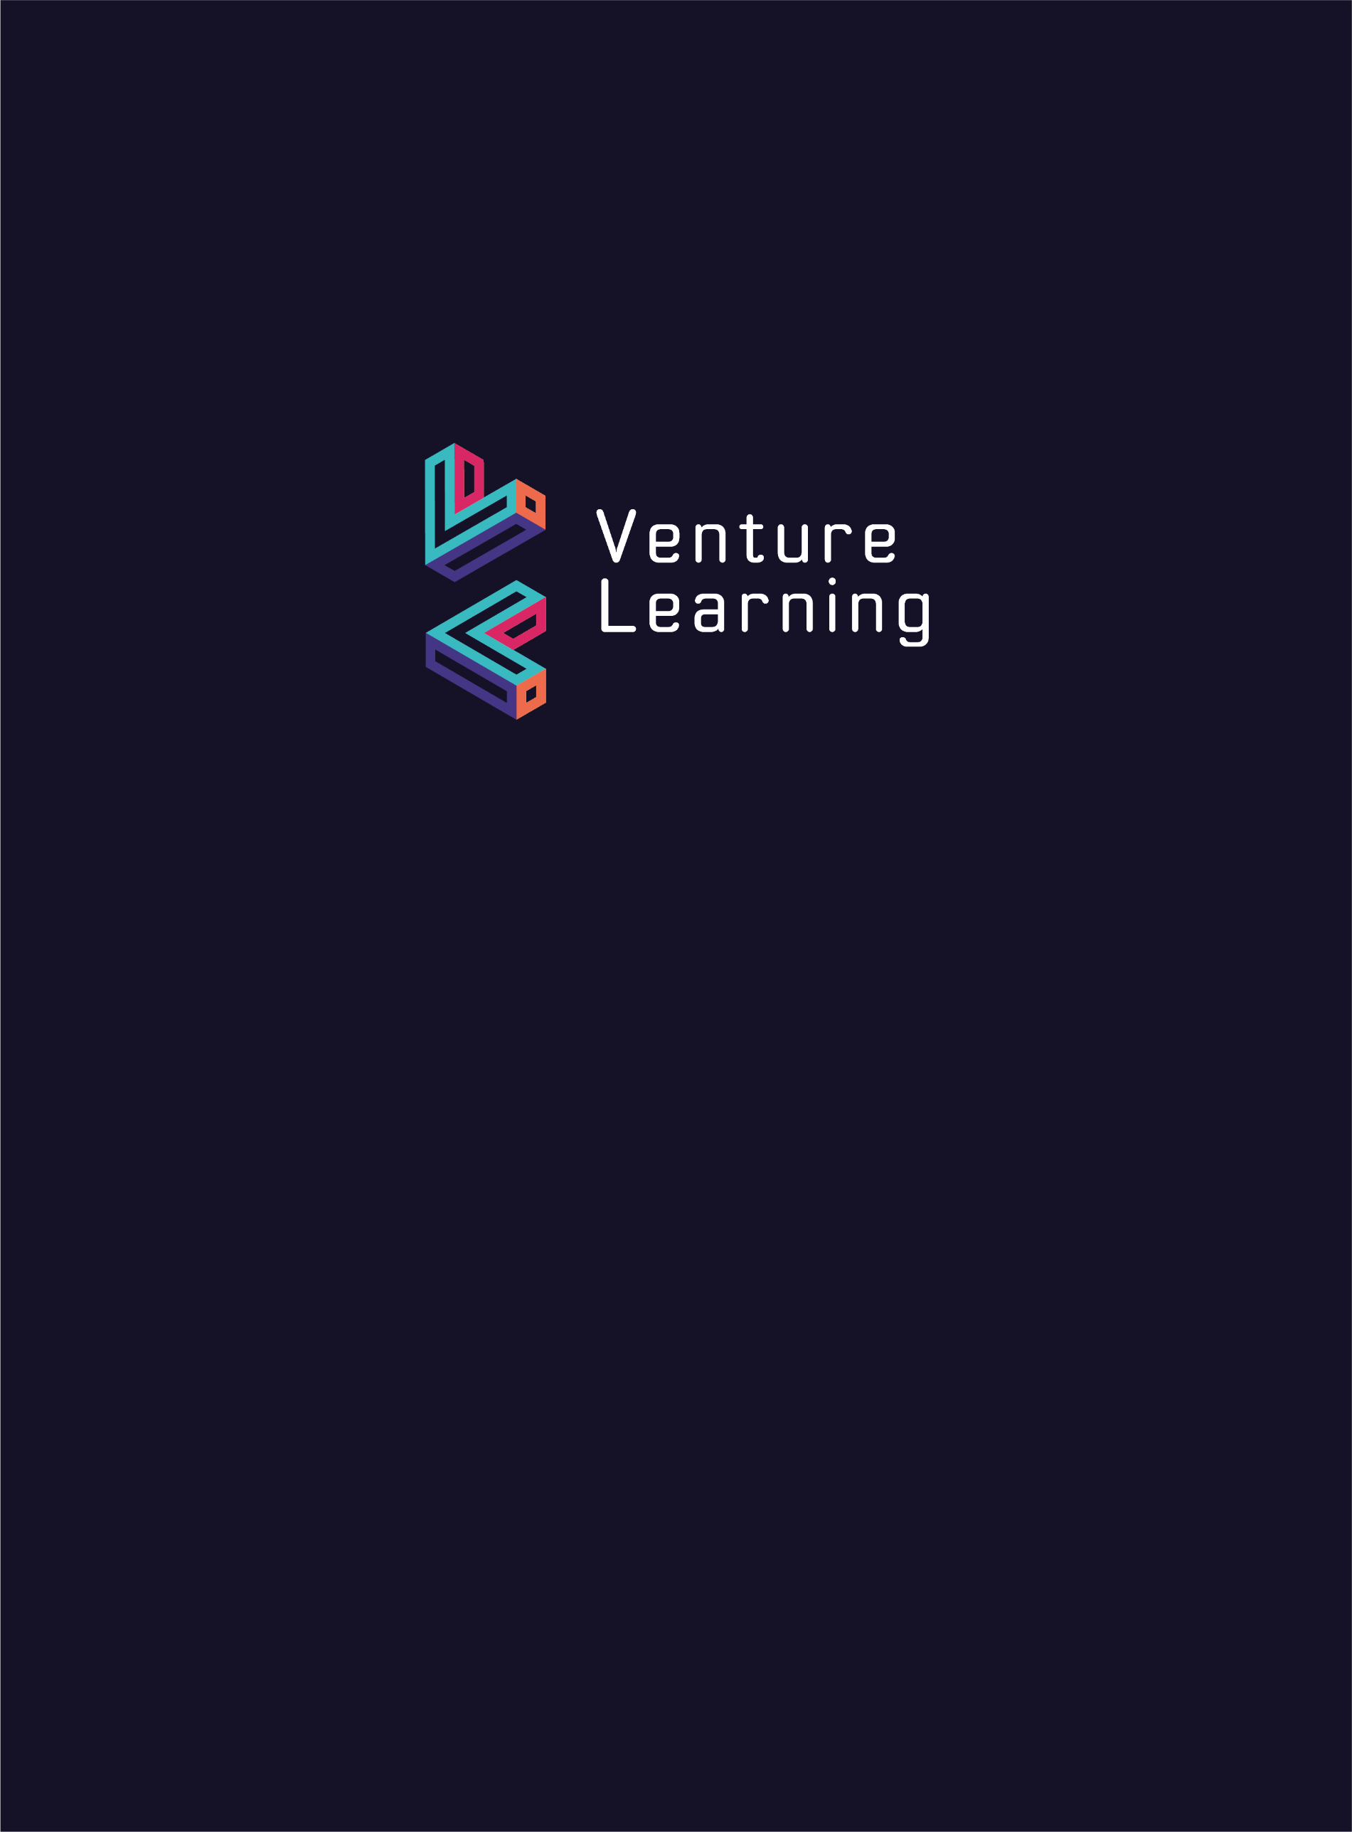

**Modern Slavery Statement**

Modern slavery is a crime and a violation of fundamental human rights. It takes various forms, such as slavery, servitude, forced and compulsory labour and human trafficking, all of which have in common the deprivation of a person's liberty by another in order to exploit them for personal or commercial gain.

We are committed to improving our practices to combat slavery and human trafficking.

We ensure that all of our staff, including temporary and agency staff are being paid at least the appropriate minimum wage and are not subjected to excessive working hours or unsafe working conditions. We require the agencies we use to have proof that staff have the right to work in the UK.

Venture Learning aims to continually develop links with local business and access opportunities in our community. We encourage all our staff to be aware of modern slavery and to report any concerns they have of slaver occurring in an organisation we may be involved with. Venture Learning will not do business with any organisation that we believe may be engaging in modern slavery.

‘Spot the Signs’ offers advice and guidance on how to spot signs of modern slavery:

<https://www.unseenuk.org/learn-more/general/spot-the-signs?gclid=CjwKCAiAwJTjBRBhEiwA56V7q2hnkdRg9oSEd8nY3Ibh3Wl0J_yJpaZTm8lJAiBPU_IVSSSWvVJujxoCqZMQAvD_BwE>

Concerns about modern slavery and exploitation can be reported on:

Modern Slavery Helpline: 0800 0121 700

Crimestoppers: 0800 555 111

Guidance on the Modern Slavery Act UK 2015 can be found at [Modern Slavery Act 2015 - GOV.UK (www.gov.uk)](https://www.gov.uk/government/collections/modern-slavery-bill)